**Memory Management (Part – I)**

**Topics to be covered**

* **contiguous memory allocation,**
* **paging,**
* **page table structure,**
* **segmentation,**

**CONCEPT**

* Memory consist of a large array of words or bytes, each with its own addresses
* The CPU fetches the value of the program counter
* Memory management is the one of the major function of the os
* The part of the system that manage hierarchy is called memory manager

**Memory Management Technique**

Memory Management Technique

CONTIGOUS (PARTIONED)

NON-CONTIGOUS

Single Partition

Multiple Partition

Fixed (Static)

Variable (Dynamic)

9

Demand Paging

Segmentation

Paging

**Contiguous**

* Contiguous – The main memory must accommodate both the os and the various user processes
* The main memory is usually divided into two partition one for resident os and one for user processes
* We can place os in either low memory or high memory
* Partition memory management technique come under contiguous memory management in which the user area of main memory is allocated continuously to the user

**Non –Contiguous**

* In non-contiguous memory management they allow the program to be divided in to different chunks and loaded at different portion of the memory
* It is then function of os to manage these different chunks in such a way that they appear to be contiguous

**Main Function of MM Unit**

1. Keep track of all memory location free or allocated ,and if allocated to which process and how much
2. To divide the memory allocation policy
3. To use various technique and algorithm to allocate and allocate memory location

**Base and Limit Registers**

A pair of **base** and **limit** registers define the logical address space

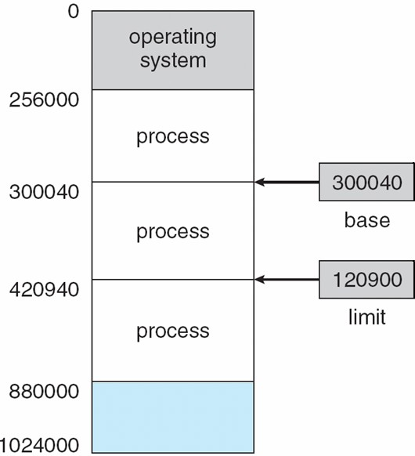

**Address Binding**

**Binding of Instructions and Data to Memory**

Address binding of instructions and data to memory addresses can happen at three different stages **Compile time**: If memory location known a priori, **absolute code** can be generated; must recompile code if starting location changes

**Load time**: Must generate **relocatable code** if memory location is not known at compile time **Execution time**: Binding delayed until run time if the process can be moved during its execution from one memory segment to another. Need hardware support for address maps (e.g., base and limit registers)

**Multistep Processing of a User Program**

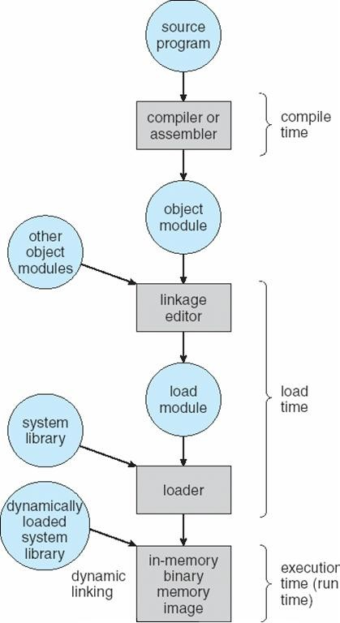

**Logical vs. Physical Address Space**

 The concept of a logical address space that is bound to a separate **physical address space** is central to proper memory management

**Logical address** – generated by the CPU; also referred to as **virtual address Physical address** – address seen by the memory unit

Logical and physical addresses are the same in compile-time and load-time address-binding schemes; logical (virtual) and physical addresses differ in execution-time address-binding scheme

**Memory-Management Unit (MMU)**

Hardware device that maps virtual to physical address

In MMU scheme, the value in the relocation register is added to every address generated by a user process at the time it is sent to memory

 The user program deals with *logical* addresses; it never sees the *real* physical addresses

**Dynamic relocation using a relocation register**

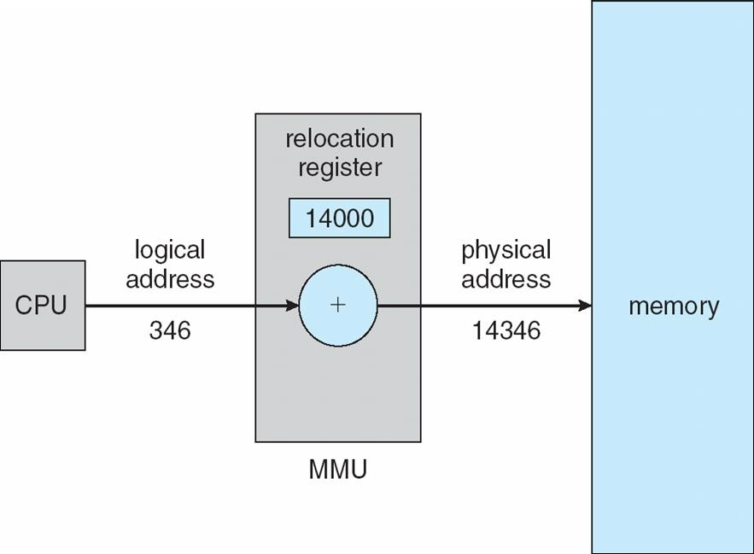

**Dynamic Loading**

Routine is not loaded until it is called

Better memory-space utilization; unused routine is never loaded

Useful when large amounts of code are needed to handle infrequently occurring cases

No special support from the operating system is required implemented through program design

**Dynamic Linking**

Linking postponed until execution time

Small piece of code, *stub*, used to locate the appropriate memory-resident library routine Stub replaces itself with the address of the routine, and executes the routine

Operating system needed to check if routine is in processes’ memory address Dynamic linking is particularly useful for libraries

System also known as **shared libraries**

**Swapping**

A process can be swapped temporarily out of memory to a backing store, and then brought back into memory for continued executionn**Backing store** – fast disk large enough to accommodate copies of all memory images for all users; must provide direct access to these memory imagesn**Roll out, roll in** – swapping variant used for priority-based scheduling algorithms; lower-priority process is swapped out so higher-priority process can be loaded and executednMajor part of swap time is transfer time; total transfer time is directly proportional to the amount of memory swappednModified versions of swapping are found on many systems (i.e., UNIX, Linux, and Windows)

System maintains a **ready queue** of ready-to-run processes which have memory images on disk

**Schematic View of Swapping**

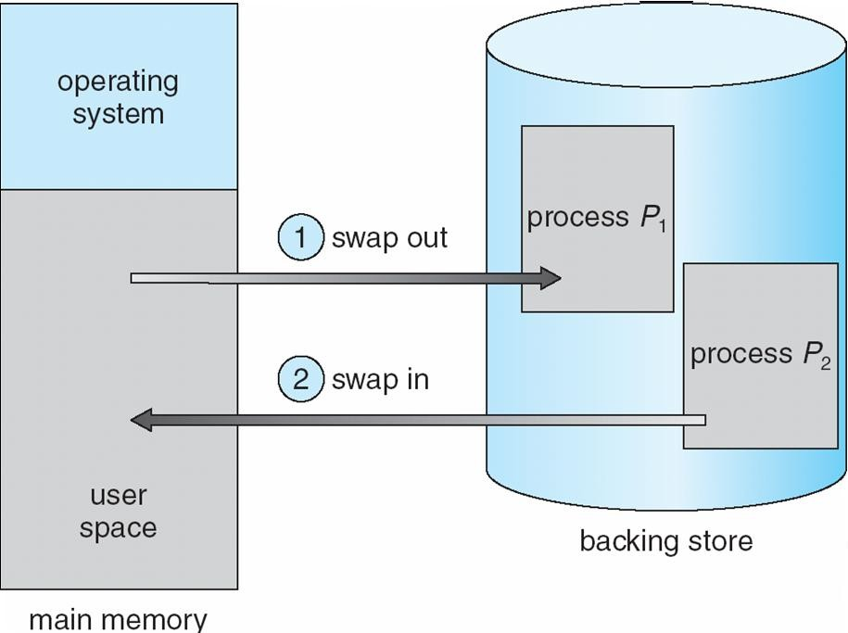

Main memory usually into two partitions:

**Contiguous Allocation**

Resident operating system, usually held in low memory with interrupt vector

User processes then held in high memorynRelocation registers used to protect user processes from each other, and from changing operating-system code and data

Base register contains value of smallest physical address

Limit register contains range of logical addresses – each logical address must be less than the limit register

 MMU maps logical address *dynamically*

**Hardware Support for Relocation and Limit Registers**

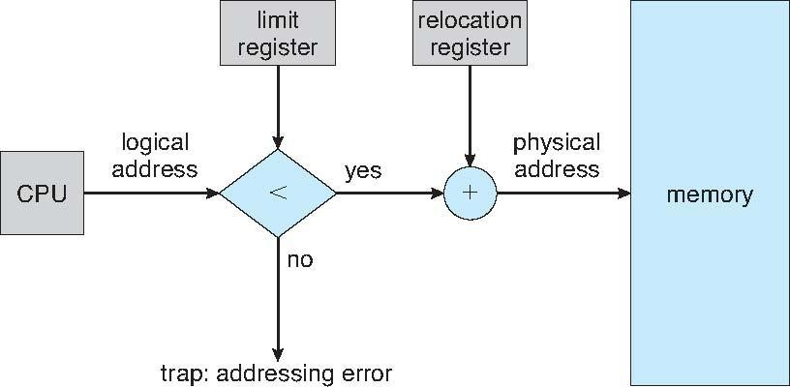



Multiple-partition allocation

Hole – block of available memory; holes of various size are scattered throughout memory When a process arrives, it is allocated memory from a hole large enough to accommodate it

 Operating system maintains information about:

 a) allocated partitions b) free partitions (hole)

|  |
| --- |
| OS |
| process 5 |
| process 8 |
| process 2 |

|  |
| --- |
| OS |
| process 5 |
|  |
| process 2 |

|  |
| --- |
| OS |
| process 5 |
| process 9 |
|  |
| process 2 |

|  |
| --- |
| OS |
| process 5 |
| process 9 |
| process 10 |
|  |
| process 2 |

**Dynamic Storage-Allocation Problem**

**First-fit**: Allocate the *first* hole that is big enough

**Best-fit**: Allocate the *smallest* hole that is big enough; must search entire list, unless ordered by size Produces the smallest leftover hole

**Worst-fit**: Allocate the *largest* hole; must also search entire list Produces the largest leftover hole

First-fit and best-fit better than worst-fit in terms of speed and storage utilization

**Fragmentation**

**External Fragmentation** – total memory space exists to satisfy a request, but it is not contiguous **Internal Fragmentation** – allocated memory may be slightly larger than requested memory; this size difference is memory internal to a partition, but not being used

Reduce external fragmentation by **compaction**

Shuffle memory contents to place all free memory together in one large block Compaction is possible *only* if relocation is dynamic, and is done at execution time. I/O problem



Latch job in memory while it is involved in I/O

Do I/O only into OS buffers

**PRACTICE PROBLEMS BASED ON CONTIGUOUS MEMORY ALLOCATION-**

**Problem-01:**

Consider six memory partitions of size 200 KB, 400 KB, 600 KB, 500 KB, 300 KB and 250 KB. These partitions need to be allocated to four processes of sizes 357 KB, 210 KB, 468 KB and 491 KB in that order.

* Perform the allocation of processes using-
* First Fit Algorithm
* Best Fit Algorithm
* Worst Fit Algorithm
* **Solution-**

According to question,

* The main memory has been divided into fixed size partitions as-

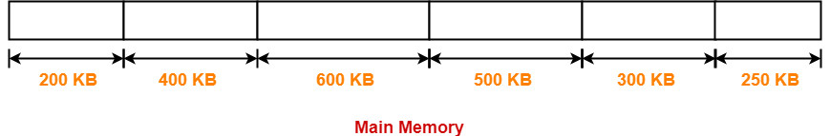

Let us say the given processes are-

Process P1 = 357 KB

Process P2 = 210 KB

Process P3 = 468 KB

Process P4 = 491 KB

**Allocation Using First Fit Algorithm-**

* In First Fit Algorithm,
* Algorithm starts scanning the partitions serially.
* When a partition big enough to store the process is found, it allocates that partition to the process.
* The allocation of partitions to the given processes is shown below-

**Step-01:**



* **Step-02:**

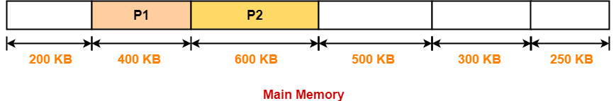

**Step-03:**

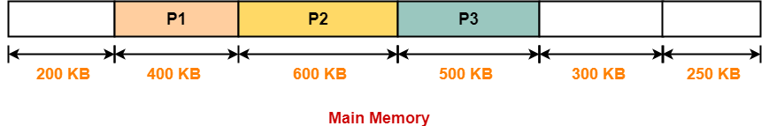

* **Step-04:**

**Process P4 cannot be allocated the memory.**

**This is because no partition of size greater than or equal to the size of process P4 is available.**

**Allocation Using Best Fit Algorithm-**

* **In Best Fit Algorithm,**
* **Algorithm first scans all the partitions.**
* **It then allocates the partition of smallest size that can store the process.**
* **The allocation of partitions to the given processes is shown below-**

**Step-01:**

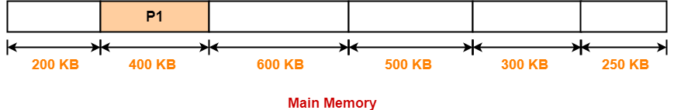

**Step-02:**

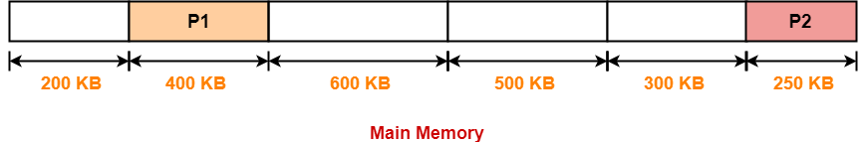

* **Step-03:**

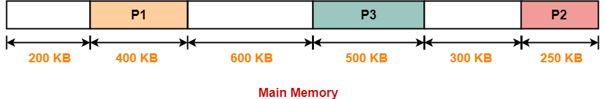

**Step-04:**

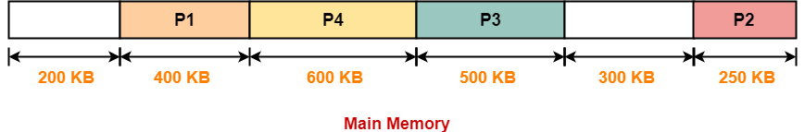

**Allocation Using Worst Fit Algorithm-**

**Worst Fit**

* In Worst Fit Algorithm,
* Algorithm first scans all the partitions.
* It then allocates the partition of largest size to the process.
* The allocation of partitions to the given processes is shown below-

**Step-01:**

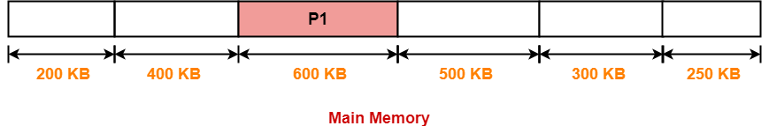

**Step-02:**

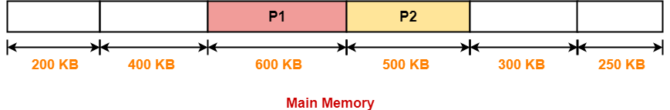

**Step-03:**

**Process P3 and Process P4 can not be allocated the memory.**

**This is because no partition of size greater than or equal to the size of process P3 and process P4 is available.**

**Paging**

 Logical address space of a process can be noncontiguous; process is allocated physical memory whenever the latter is available

 Divide physical memory into fixed-sized blocks called **frames** (size is power of 2, between 512 bytes and 8,192 bytes)

Divide logical memory into blocks of same size called **pages** n Keep track of all free frames

* Physical address space of a process can be noncontiguous; process is allocated physical memory whenever the latter is available
  + Avoids external fragmentation
  + Avoids problem of varying sized memory chunks
* Divide physical memory into fixed-sized blocks called **frames**
  + Size is power of 2, between 512 bytes and 16 Mbytes
* Divide logical memory into blocks of same size called **pages**
* Keep track of all free frames
* To run a program of size ***N*** pages, need to find ***N*** free frames and load program
* Set up a **page table** to translate logical to physical addresses
* Backing store likewise split into pages
* Still have Internal fragmentation

**Address Translation Scheme**

Address generated by CPU is divided into

**Page number (*p*)** – used as an index into a *page table* which contains base address of each page in physical memory

 **Page offset (d)** – combined with base address to define the physical memory address that is sent to the memory unit

 For given logical address space 2*m and page size 2*n

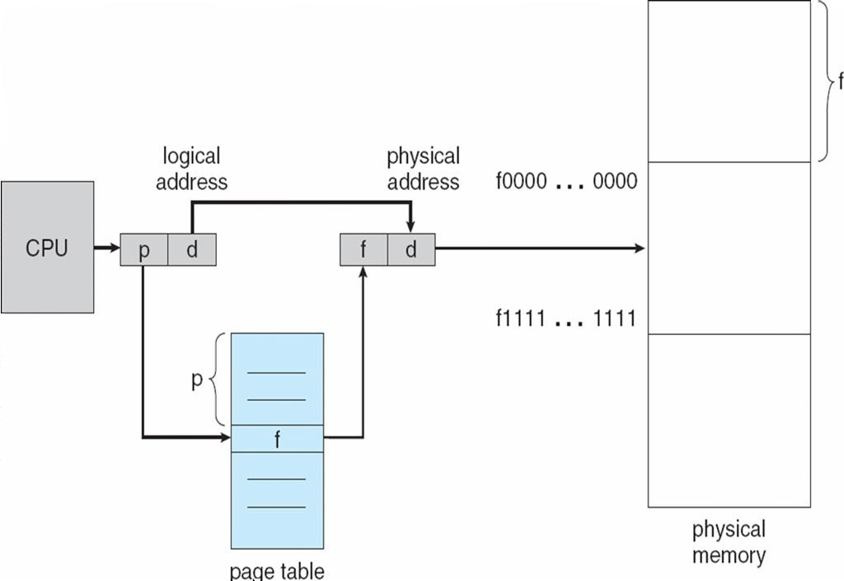**Paging Hardware**

page number page offset

*p d*

*m - n n*

|  |  |
| --- | --- |
|  |  |
|  |  |

**Paging Model of Logical and Physical Memory**

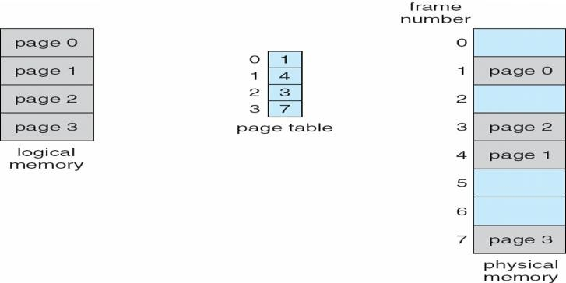

**Paging Example**

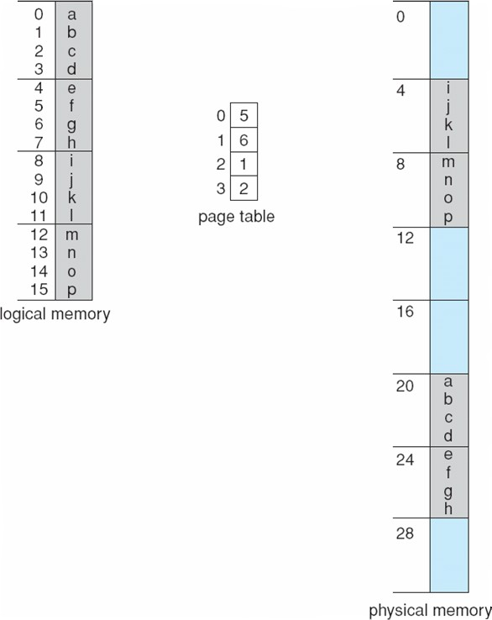

**32-byte memory and 4-byte pages**

**Free Frames**

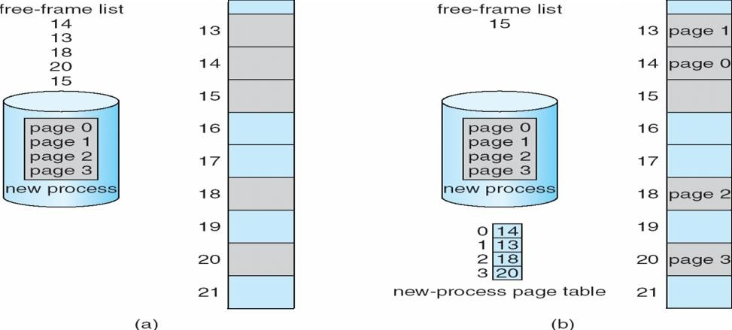

**Implementation of Page Table**

Page table is kept in main memory

**Page-table base register (PTBR)** points to the page table

**Page-table length register (PRLR)** indicates size of the page table

In this scheme every data/instruction access requires two memory accesses. One for the page table and one for the data/instruction.

 The two memory access problem can be solved by the use of a special fast-lookup hardware cache called **associative memory** or **translation look-aside buffers (TLBs)**

 Some TLBs store **address-space identifiers (ASIDs)** in each TLB entry – uniquely identifies each process to provide address-space protection for that process

**Associative Memory**

Associative memory – parallel search Address translation (p, d)

If p is in associative register, get frame # out Otherwise get frame # from page table in memory

|  |  |
| --- | --- |
| Page # | Frame # |
|  |  |
|  |  |
|  |  |
|  |  |

**Paging Hardware With TLB**

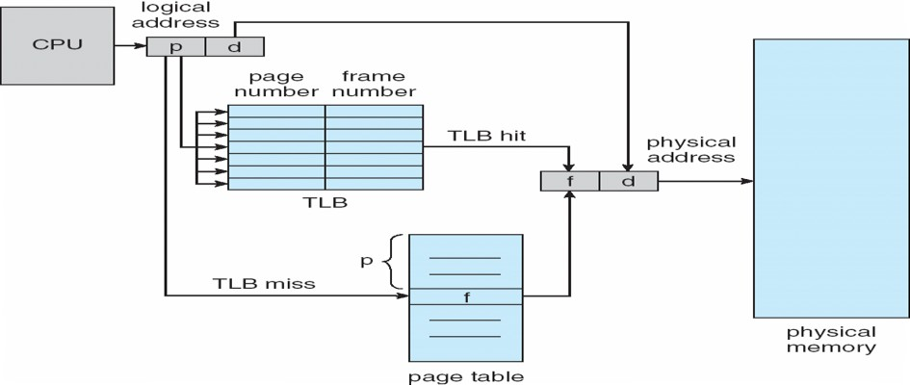

**Effective Access Time**

Associative Lookup = e time unit

Assume memory cycle time is 1 microsecond

Hit ratio – percentage of times that a page number is found in the associative registers; ratio related to number of associative registers

 Hit ratio = an **Effective Access Time** (EAT)

EAT = (1 + e) a + (2 + e)(1 – a)

= 2 + e – a

**Memory Protection**

Memory protection implemented by associating protection bit with each frame

**Valid-invalid** bit attached to each entry in the page table:

“valid” indicates that the associated page is in the process’ logical address space, and is thus a legal page “invalid” indicates that the page is not in the process’ logical address space

**Valid (v) or Invalid (i) Bit In A Page Table**

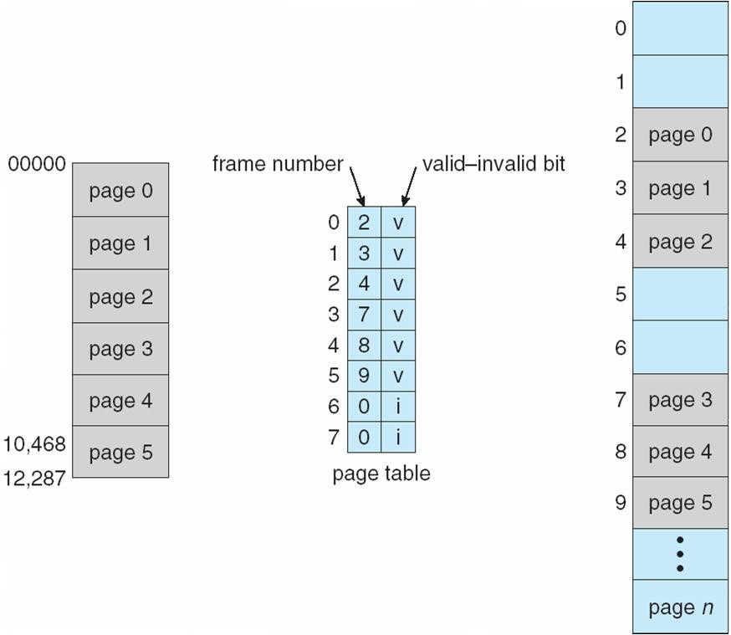

**Shared Pages Shared code**

 One copy of read-only (reentrant) code shared among processes (i.e., text editors, compilers, window systems).

 Shared code must appear in same location in the logical address space of all processes

**Private code and data**

Each process keeps a separate copy of the code and data

The pages for the private code and data can appear anywhere in the logical address space

**Shared Pages Example**

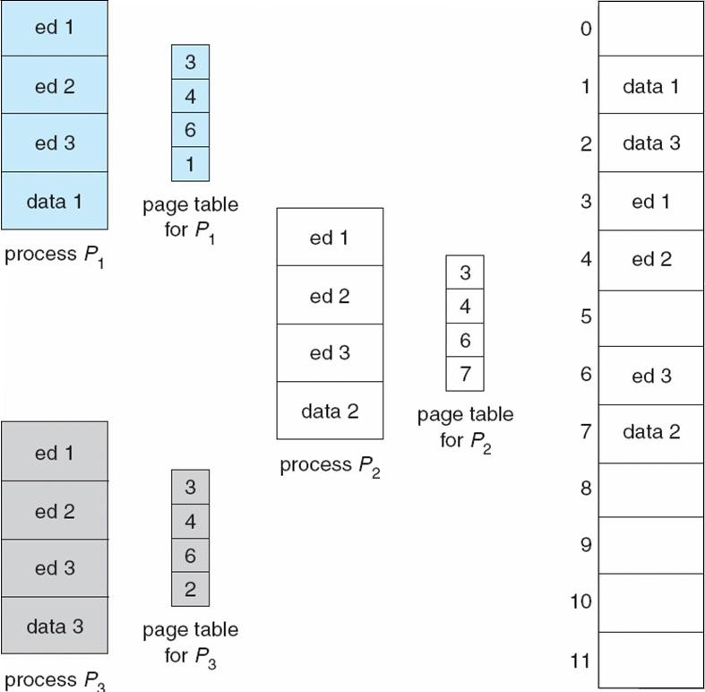

**Structure of the Page Table**

Hierarchical Paging Hashed Page Tables Inverted Page Tables

**Hierarchical Page Tables**

Break up the logical address space into multiple page tables A simple technique is a two-level page table

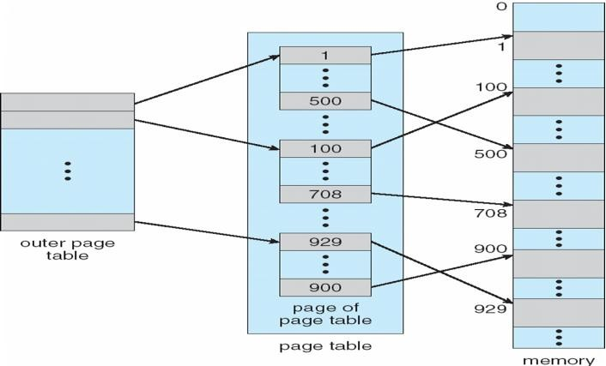**Two-Level Page-Table Scheme**

Dept. of Computer Science and Engineering Page

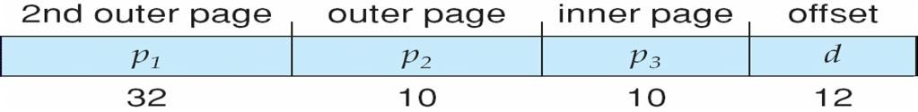

**Two-Level Paging Example**

A logical address (on 32-bit machine with 1K page size) is divided into: a page number consisting of 22 bits

a page offset consisting of 10 bits

Since the page table is paged, the page number is further divided into:

a 12-bit page number a 10-bit page offset

Thus, a logical address is as follows:

where *pi* is an index into the outer page table, and *p2* is the displacement within the page of the outer page table

p

|  |  |  |
| --- | --- | --- |
| age number | | page offset |
| *p*i | *p*2 | *d* |

12 10 10

**Address-Translation Scheme**

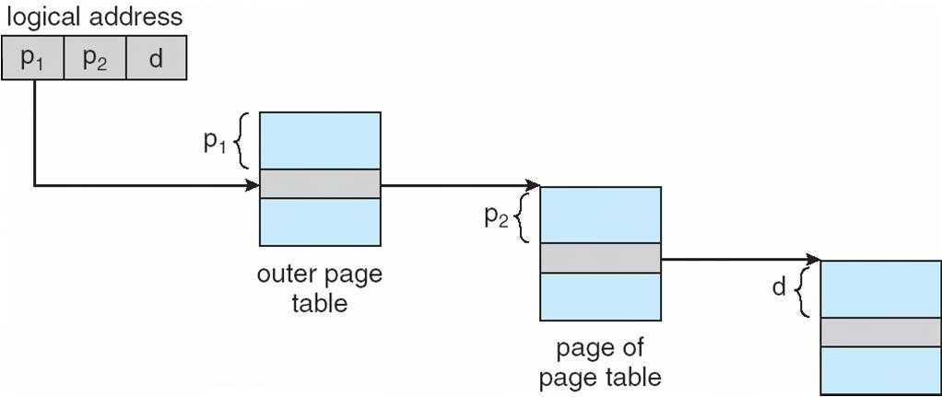

**Three-level Paging Scheme**

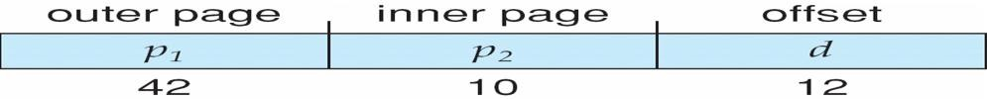

**Hashed Page Tables**

Common in address spaces > 32 bits

The virtual page number is hashed into a page table

This page table contains a chain of elements hashing to the same location Virtual page numbers are compared in this chain searching for a match

If a match is found, the corresponding physical frame is extracted

**Hashed Page Table**

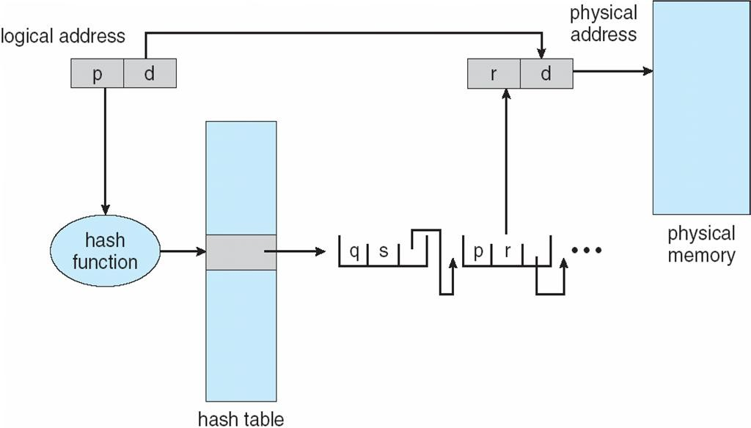

**Inverted Page Table**

One entry for each real page of memory

Entry consists of the virtual address of the page stored in that real memory location, with information about the process that owns that page

 Decreases memory needed to store each page table, but increases time needed to search the table when a page reference occurs

Use hash table to limit the search to one — or at most a few — page-table entries

**Inverted Page Table Architecture**

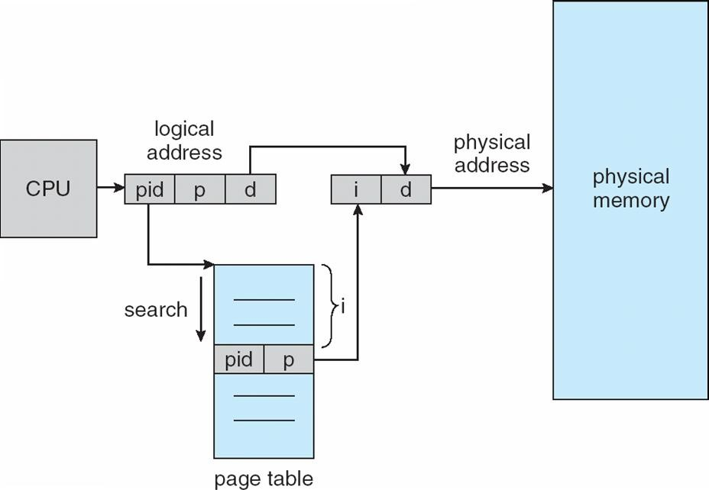

**Segmentation**

Memory-management scheme that supports user view of memory A program is a collection of segments

A segment is a logical unit such as: main program

procedure function method

object

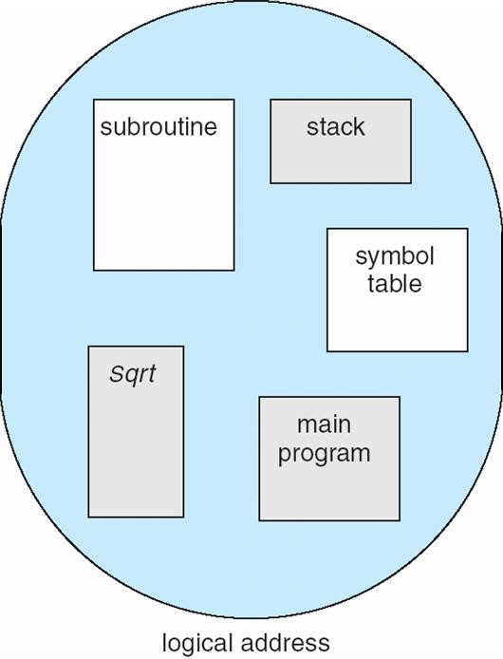local variables, global variables common block

stack symbol table arrays

**User’s View of a Program**

**Logical View of Segmentation**

|  |
| --- |
| 1 |
| 4 |
|  |
|  |
| 2 |
| 3 |
|  |

4

3

2

1

user space

**Segmentation Architecture**

 Logical address consists of a two tuple:

o <segment-number, offset>,

**Segment table** – maps two-dimensional physical adpdrhesysess;iecaachltambleeemntroy rhyas

**base** – contains the starting physical address where the segments reside in memory

**limit** – specifies the length of the segment

**Segment-table base register (STBR)** points to the segment table’s location in memory

**Segment-table length register (STLR)** indicates number of segments used by a program; segment number ***s*** is legal if ***s*** < **STLR**

Protection

With each entry in segment table associate:

validation bit = 0 Þ illegal segment read/write/execute privileges



Protection bits associated with segments; code sharing occurs at segment level

Since segments vary in length, memory allocation is a dynamic storage-allocation problem A segmentation example is shown in the following diagram

**Segmentation Hardware**

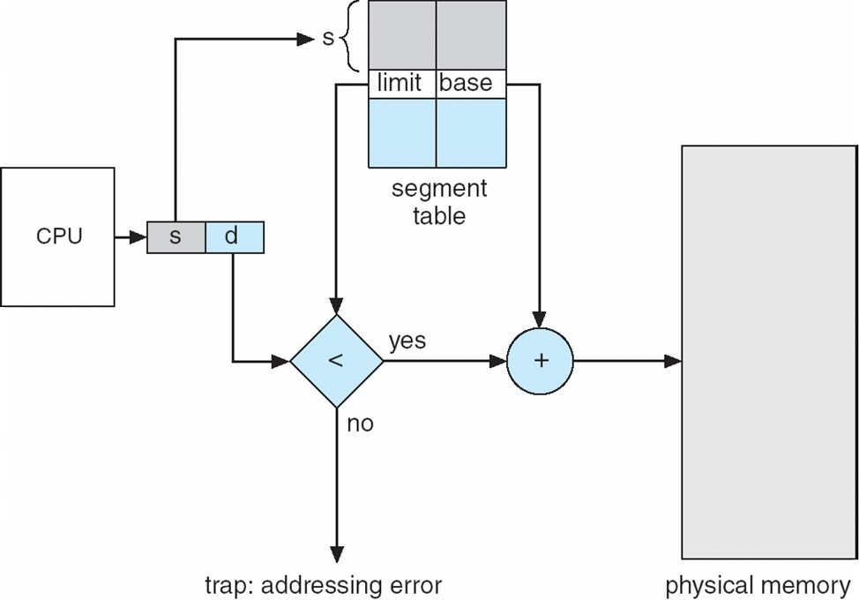

**Example of Segmentation**

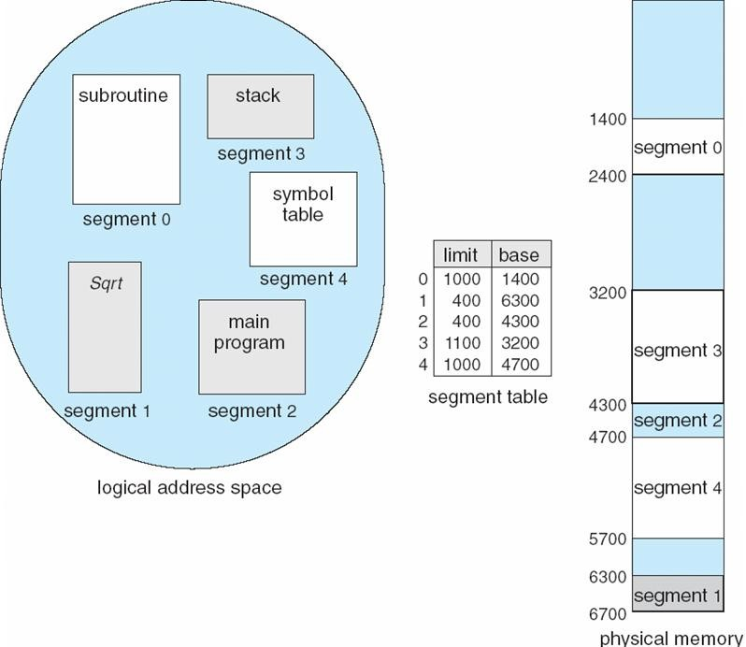

**Example: The Intel Pentium**

Supports both segmentation and segmentation with paging CPU generates logical address

Given to segmentation unit

Which produces linear addresses  Linear address given to paging unit



Which generates physical address in main memory Paging units form equivalent of MMU

**Logical to Physical Address Translation in Pentium**

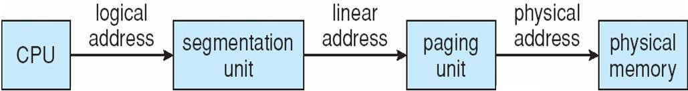

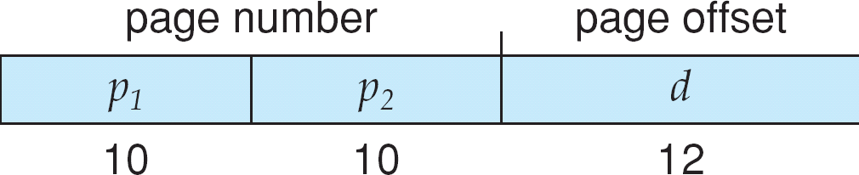

**Intel Pentium Segmentation**

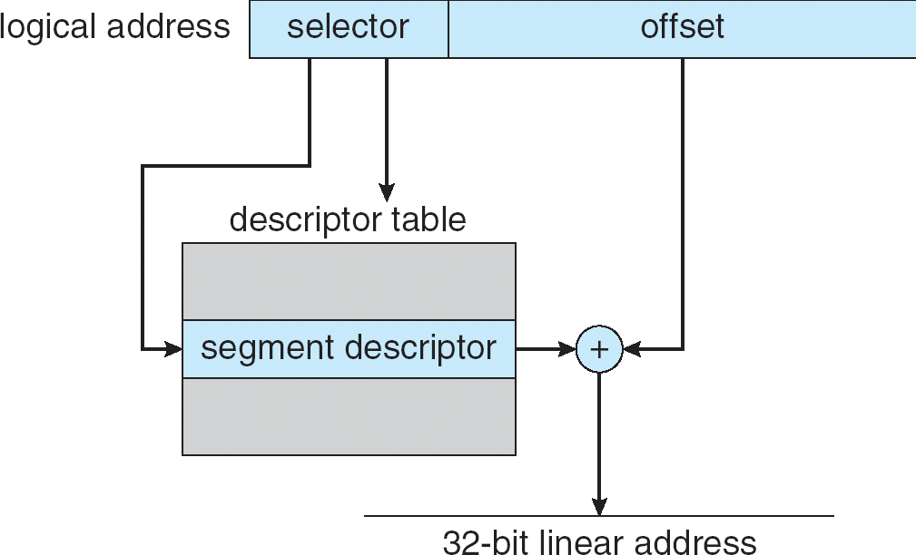

**Pentium Paging Architecture**

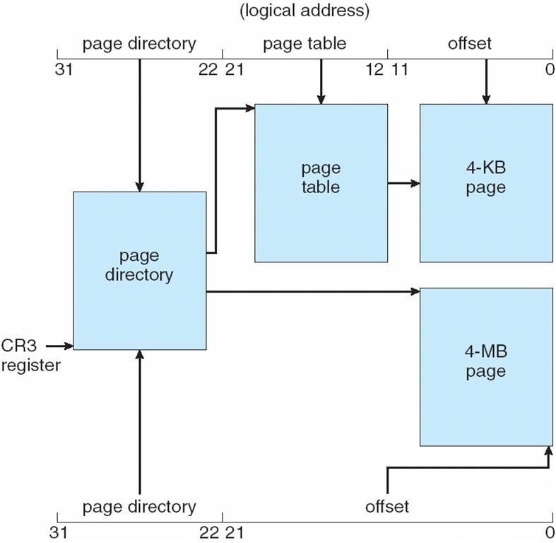

**Linear Address in Linux**

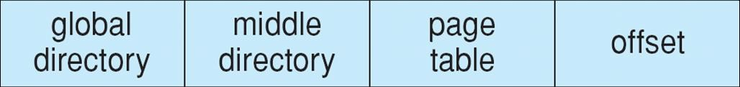

**Three-level Paging in Linux**

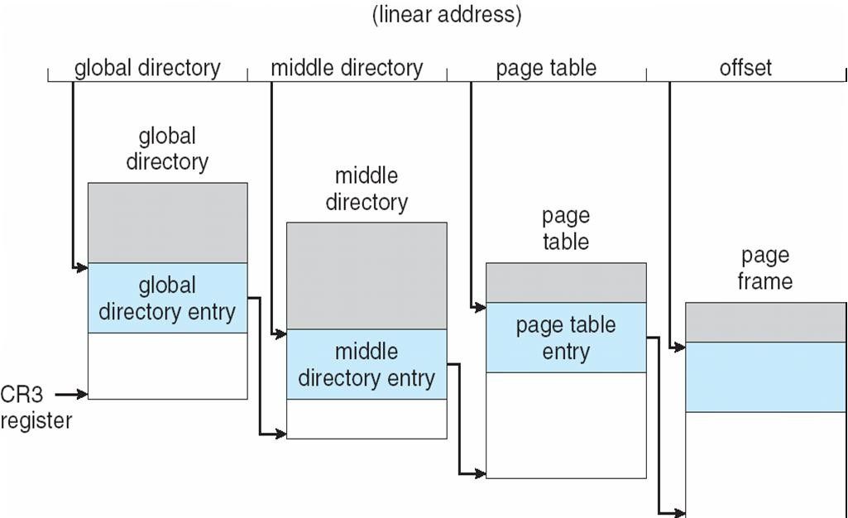

**Difference between Paging and Segmentation:**

| **S.NO** | **PAGING** | **SEGMENTATION** |
| --- | --- | --- |
| 1. | In paging, program is divided into fixed or mounted size pages. | In segmentation, program is divided into variable size sections. |
| 2. | For paging operating system is accountable. | For segmentation compiler is accountable. |
| 3. | Page size is determined by hardware. | Here, the section size is given by the user. |
| 4. | It is faster in the comparison of segmentation. | Segmentation is slow. |
| 5. | Paging could result in internal fragmentation. | Segmentation could result in external fragmentation. |
| 6. | In paging, logical address is split into page number and page offset. | Here, logical address is split into section number and section offset. |
| 7. | Paging comprises a page table which encloses the base address of every page. | While segmentation also comprises the segment table which encloses segment number and segment offset. |
| 8. | Page table is employed to keep up the page data. | Section Table maintains the section data. |
| 9. | In paging, operating system must maintain a free frame list. | In segmentation, operating system maintain a list of holes in main memory. |
| 10. | Paging is invisible to the user. | Segmentation is visible to the user. |
| 11. | In paging, processor needs page number, offset to calculate absolute address. | In segmentation, processor uses segment number, offset to calculate full address. |

**Segmentation with Paging**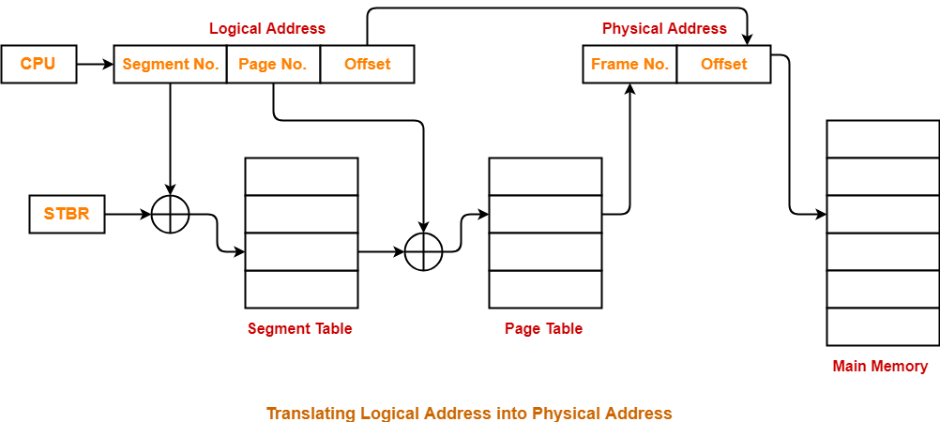

**Segmented paging is a scheme that implements the combination of segmentation and paging.[eg MULTICS]**

**Working-**

**In segmented paging,**

* **Process is first divided into segments and then each segment is divided into pages.**
* **These pages are then stored in the frames of main memory.**
* **A page table exists for each segment that keeps track of the frames storing the pages of that segment.**
* **Each page table occupies one frame in the main memory.**
* **Number of entries in the page table of a segment = Number of pages that segment is divided.**
* **A segment table exists that keeps track of the frames storing the page tables of segments.**
* **Number of entries in the segment table of a process = Number of segments that process is divided.**
* **The base address of the segment table is stored in the segment table base register.**